Child’s Name………………………………… CHARTER Class……………………………

The school will
- Provide every child with access to a broad and balanced curriculum that will help all children to maximise their potential.
- Ensure all children and adults are aware of our school charters (the playground charter displayed outside the main entrance and the side of Poppy Class and individual class charters which are written each September and reviewed termly). Encourage everyone to adopt them consistently.
- Actively model and encourage our Trafalgar Core Values (see our Trafalgar Ship attached).
- Inform parents/carers regularly of children’s progress and provide an annual written report.
- Involve parents/carers and children in planning what the children would like to learn in relation to topic work.
- Be open and welcoming, offering good opportunities to become involved in the life of the school.
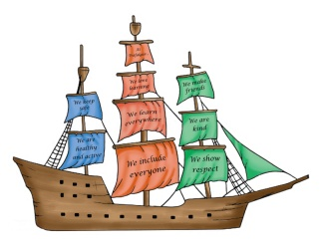
- Recognise and reward success and achievement in a therapeutic way.
- Provide a safe environment for children to learn and develop.
- Support and teach children to behave in the correct way.
Headteachers’ Signature 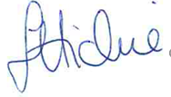

The family will
- Support the core values and ethos of the school community.
- Ensure my child attends regularly, arrives on time and with everything needed for the day.
- Inform the school as soon as possible if my child cannot attend.
- Support my child with ‘homework’ and general opportunities for learning at home.
- Let the school know of any issues or concerns which are affecting my child’s work.
- Attend parents’ meetings and discussions about my child’s progress.
- Support my child to understand and follow the school charters.

Parent/Carer Signature ………………………………………….

Children
I have the responsibility to …
- Do my best to follow the school charters and core values.
- Act responsibly and be a kind, thoughtful and good role model.
- Be polite to everyone I meet in school.
- Try to keep myself and others safe.
- Listen and work as well as I can
- Take care of my school and all the resources I use while I am in school.

Child’s Signature ……………………………………………………

Together we will …
- Value the efforts of all involved with the school.
- Promote behaviour for learning and positive attitudes towards school.
- Form constructive relationships built on trust and mutual respect.
- Support learning to help us all achieve our best.

Trafalgar is a Rights Respecting School. This is a UNICEF award which is based on the Rights of the Child (UNCRC). The UNCRC is a series of 54 articles that lay down the rights of all children and young people under the age of 18.
Article 28
Every child has the right to an education.
Article 29
Education must develop every child’s personality, talents and abilities to the full. It must encourage the child’s respect for human rights, as well as respect for their parents, their own and other cultures, and the environment.

Our Core Values
